Game Dev Share, LLC

Game Developer Job Listing & Marketplace Site

[www.gdshare.io/EN/](http://www.gdshare.io/EN/)

**BUSINESS PLAN SUMMARY V1.0**

**-DRAFT-**

**May 2020**

Submitted By:  
Riley Payung, Tyler Fields, Ceasar Howe, Matthew McMeekin

**PROPRIETARY AND CONFIDENTIAL**

The information contained herein is proprietary and confidential to Game Dev Share, LLC. It is offered with the express agreement that the recipient will not disclose this plan to any other person(s), or discuss the information contained in it or make a reproduction by any means electronic or mechanical, or use the information for any purpose other than evaluating it for participation. Any recipient or reader accepts full legal liability for protecting this document’s confidentiality.

**CONTENTS**

**Description of Business**  
 Overview  
 Revenue Generation  
 Benefits to Clients  
 Competitive Advantage and Barrier to Entry  
 Partnership Acquisition Strategy  
 Technology Strategy

**Management Team**  
 Biographies  
 Organizational Chart

**Sales and Marketing**  
 Market Overview  
 Target Verticals and Clients  
 Sales and Marketing Strategy  
 Marketing Campaign

**Financial Plan**

**Risks and Contingencies**

# Description of Business

## Mission Statement

“To provide a platform with a focus on creating new opportunities for both game developers and game companies.”  
  
Core Value - To bring together companies and developers

Core Purpose - To provide a platform

Visionary Goal - An unparalleled showcasing platform

## Overview

Game Dev Share is a job listing website specifically for developers in the game industry, allowing users to create a portfolio and use it as a resume. Elements of created portfolios will include artwork, designs, photos, videos, Online 3D-Viewer, plus more. A company called Art Station offers this, but only for artists; we will broaden this scope and involve everyone in the game development industry, including but not limited to Programmers, Artists, Level Designers, Modelers, Animators, Sound Engineers, Software Engineers, and many more. Game Dev Share is to be accessible from any web browser with scalable versions on PC/MAC/Linux and mobile platforms. The projected development timeline is for release in six (6) months.

Game Dev Share (GDS) will use general web technologies including PHP, SQL, JavaScript, and HTML/CSS to build our end product. Later down the development path this may include web development frameworks such as React, Angular, or others in order to update the existing web pages; however, that is not our focus at this time.

Game Dev share will be banking with CapitalOne, making use of their Spark Business Unlimited Checkings account which has a service fee of $35 per month which can be waived with greater than $25,000 in the account with no other fees for transactions or wires up to the 5th wire transfer each month, as well as their Business Advantage Savings account which has a service fee of $3 per month which can be waived with a balance greater than $300 in the account with no other fees for transactions up to the generic 6th transaction per month and has a 1.25% APY up to a balance of $5M, ranging from 0.40% to 1.25% thereafter.

Game Dev share will be involved with law with McClanahan Powers, PLLC. for its law needs. It is estimated that our legal retainer fees will be approx. $250 per month.

## Game Dev Share Job-Board Platform Description

### Homepage

When the user loads into the site (<https://www.gdshare.io/EN/>), they will immediately see the following:

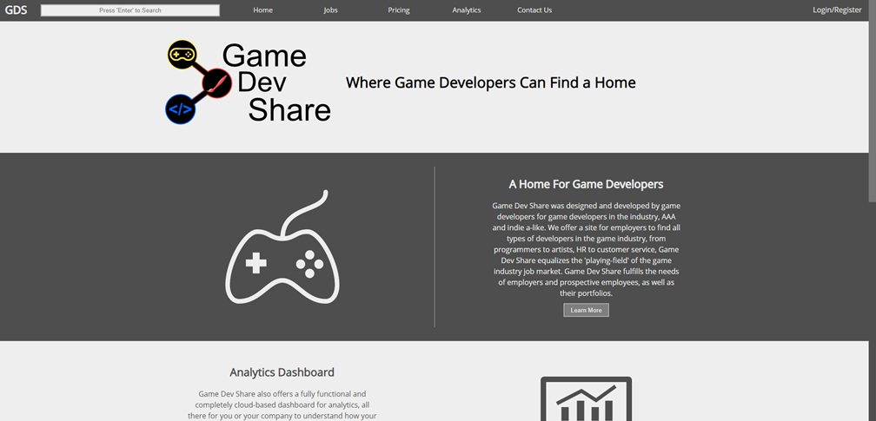

Which will include sections about the company, portfolio creation, user friendly analytics dashboards.

### Searching

There are multiple areas of the website that allow for searching.

On the homepage, users and companies can search for anything that they may find on the website, including for each other, job listings, softwares, marketplace items, and more. This ‘smart search’ algorithm will attempt to direct the user to the most relevant search page, either job search, company search, user search, or marketplace, and if there is not enough of a support for certain pages, the search will direct the user to the search results page, which will populate with the most relevant information to their search. Most of our work will be done on this algorithm to help our users find information about each other. Search results will appear with filtering for the different types of search terms that appear.

On the Job search page, users can search directly for job listings. The search results that appear will be job listings that are most relevant to the user’s search. If a job listing has enough support to find a match, it will be appended to the list of possible results, then displayed. The job can be filtered to refine the search results for job listings. At least one (1) sponsored listing will appear at the top of each page. When the user loads the page, before any searching has been done, the page will show mostly sponsored listings.

On our Marketplace page, users will be able to search directly for marketplace items. The search results that appear will be marketplace listings that are most relevant to the user’s search criteria. If an item has enough support to find a match, it will be displayed with the results. Marketplace items can be filtered to refine results. At least three (3) sponsored items will appear at the top of each page, changing when a user loads a new page of results. When the user loads the page, before any searching has been done, the page will show mostly sponsored items.

On the Company/User search page, users can search directly for users and or companies. The search results that appear will be other users or companies that are most relevant to the user’s search. Premium users will appear on top of non-premium users with support values greater than a certain threshold.

### Marketplace

The marketplace is an area of the website that users can use to sell digital goods to other users. Items will include 2D art, 3D art, Animations, Music, Sounds, Scripts, Plugins, and more. The marketplace will have its own search bar where users can search for anything. Pricing will be relative and set by the user, with a maximum price of $200. The marketplace will display its own navigation pane below the search bar that contains the type of item that the user is looking for. The navigation will also contain the shopping cart along with the total price and number of items that the user has in his/her cart. When the user presses the cart icon, it will load an overlay pane with all of the items in his/her cart. Search results can be filtered by using the side navigation in which the user can select certain or specific filters. Sorting can be done by using the dropbox next to the word sort, which will include: Best Match, Price Low to High, Price High to Low, Alphabetically, and by Rating. The same area will include a button that the user can click to create their own marketplace item, which will redirect them to the login page if they are not logged in, or the item creation page if they are logged in. Following that is the option to switch between grid and detailed item views. Each page will display 24-48 items. Navigating to a new page will be at the bottom of the page.

### Pricing

The pricing page will provide users with information on pricing. Pricing is multi-tiered, with two different developer pricing options and four different company pricing options. Users have the options of basic or premium services, with discounts as they increase the length of their subscription. Pricing for users starts at $9.99 per month for a month-to-month subscription, and lowers to $7.49 priced monthly for a year for a full 12-month subscription at $89.88.

Pricing for companies is based on the job option that they choose. Companies can also pre-pay for job listings. Free, Advantage, Advantage+, and Unlimited plans are available. Free job listings cost nothing for the first five (5) applicants, and $1.75 per applicant thereafter. Advantage listings cost $500 for the base price, with 100 free applicants, and $1.00 per applicant thereafter. Advantage listings also get improved search results, some limited automated email marketing, and marketing campaign provisioning can be applied to improve the listing. Advantage+ listings base cost is $1000, with 300 free applicants, and costing $0.75 per applicant thereafter. Advantage+ listings also get improved search results, automated email marketing, and marketing campaign provisioning can be applied to improve the listing. Unlimited Listings base cost is $2,000, includes unlimited applicants, and gets improved search results, shows up first in automated email marketing, and marketing campaign provisioning can be applied to improve the listing further.

Marketing Campaign Provisioning is an opportunity to designate additional funding for all active job listings at a company; this will allow companies to increase their advertising and engage more users. All types of marketing can have increased exposure to potential applicants. This is a prepaid service.

### Developer Portfolios

Developer portfolios will contain their own navigation that will have pages visible based on the type of user viewing. All users, including companies will be able to see the Overview, Project, and Marketplace navigation options. Only the owner will be able to see the Analytics, My Appearance, and Settings navigation options.

The Overview page will contain information about the user, their work experience, as well as a set of projects and a set of marketplace items. Their portfolio will also contain contact information always available to companies unless they choose to prevent this option in their settings. The overview will also display the user’s rankings on the website including their top marketplace category. Users are able to set their own title and location. Premium users will have a golden star next to their name.

The projects page will contain projects of certain categories that the user has created. The user can choose how to display this on their portfolio.

The Marketplace page, also visible to all users, will contain the user’s released items that they have on the marketplace. This is also where they can create, edit, hide, or delete marketplace items. Each item on this page has the option of editing, analyzing earnings, deleting, hiding or to create a new item. This page will also show some analytics that the user can see that will display some statistics, including their number one category, number of total sales, total monetary value of generated sales, and their cut of the sales. The user can also download the data or analyze more data. The graph is based on a yearly schedule and can be switched to different views and broken down into quarterly earnings, depending on how the user wishes to see them.

The Analytics page, visible only to the portfolio owner, will contain a state of the art analytics dashboard that users can use to make better decisions based on their history on the website. The analytics displayed here will include marketplace overviews and their appearance in job searches.

The My Appearance page, visible only to the portfolio owner, will contain all of the job listings that the user has applied to as well as the current state of their application.

The Settings page, visible only to the portfolio owner, will have its own sub-navigation containing general, email, analytics, and other settings.

The general settings include user information, including their address, phone number, logo, title, billing address, visibility, and more.

The analytics settings will allow the user to change whether they appear in global rankings, etc.

Email settings contain settings to change email notifications for job listings, marketplaces, and more.

Other settings include miscellaneous settings.

### Company Portfolios

Company portfolios will contain their own navigation that will have pages visible based on the type of user viewing. The company’s employees and executives will be able to see the Overview, Projects, Analytics, Listings, Marketplace, and Settings navigation options. Users viewing the company’s portfolio will only be able to see the Overview, Projects, Listing and Marketplace navigation Options.

The Overview page will contain general information about the company and a few of each of the navigation options.

The Analytics page, visible only to the company and its employees, will contain a state of the art analytics dashboard that companies can use to make better decisions based on their history on the website. The analytics displayed here will include marketplace overviews and job listings information.

The Listings page, visible to all users will contain job listings posted by the company. For employees, this page will be where they can create, edit, hide, or end listings. Each listing on this page of the company’s portfolio has the option of editing, hiding, downloading, deleting or ending, duplicating, or performing a cost analysis. The listings page is also where companies can see their invoices.

The Marketplace page, also visible to all users, will contain the company’s released items that they have on the marketplace. This is also where they can create, edit, hide, or delete marketplace items. Each item on this page has the option of editing, analyzing earnings, deleting, hiding or to create a new item. This page will also show some analytics that the company can see that will display some statistics, including their number one category, number of total sales, total monetary value of generated sales, and their cut of the sales. The company can also download the data or analyze more data. The graph is based on a yearly schedule and can be switched to different views and broken down into quarterly earnings, depending on how the employee or company executive wishes to see them.

The settings page, visible only to the company executive, has its own sub-navigation elements that are similar to the login page. The settings categories that are changeable are general, authorizations, email, and other.

The general settings include business information, including their address, company executive information, phone number, company logo, company banner that's visible on the company’s portfolio, company slogan, company billing address, visibility, and more.

The authorizations page contains settings to change ownership of the company to another user on the site, company employees, and permissions for employees.

Email settings contain settings to change email notifications for job listings, marketplaces, invoices, and more.

Other settings include miscellaneous settings.

### Login/Registering

Logging into the website is done simply by clicking the login/register button at the top right of the website and entering the user’s credentials. Unlike many other job-market websites, we will not require that companies log in on a different page than our developer users.

There are multiple types of users:

1. Generic User
2. Company Executive
3. Company Employee

Generic User - When a user signs up looking for work, they should choose this account type, and create a generic portfolio. Users of this type are able to apply for work at companies.

Company Executive - When a user signs up looking to post job listings, they can create their own organization (company); executive users will be in charge of the organization (company), and can add users to their organization by inviting them through email. If a user exists, or a user does not exist, they will receive an invitation to be a user through email, which will make his/her account a company employee account (moderator). Executives can remove employees in the same place that they can send invitations from. Executives can also choose to require that their employees obtain approval prior to listing a job listing. Charges for a job listing will not be applied until after approval has been obtained. In order for a company executive account to be created, the company account must first be created, and the person who is in charge of handling that company’s GDS services must create his/her own account and use the company’s secret key to link his/her account to the company.

Company Moderator - When a company has multiple employees that they wish to allow access to their GDS page, they can create moderator accounts. Creating a moderator account requires that the employee inputs the company’s Employee Key to link his/her account. Executives can link employees by adding a user when they know the user’s ID or by allowing the employee to enter the company’s Employee Key to quickly link the employee to the company. Options to allow employees to post job listings with or without approval are available.

When companies sign up to use our website, they will first be asked to set up an ‘Executive’ account, which can be the owner, a manager, or whoever may be in charge of job listing in the company. This can be changed later by transferring ownership of a company to another user on the website (See Company Portfolio section for more on this). Companies will be able to create job listings based on their needs, including a completely free job listing. Upon sign up to our website, companies will have 2 free Advantage listings (a $1000.00 value). This will be visible on the company’s listings dashboard.

## Revenue Generation

**Job Listings** - Companies pay for job listings, this includes final-value fees that will be due when listings end. Companies can also pre-pay for job listings for a lowered cost.

**Premium Subscriptions** - Developers pay for subscriptions for upgraded appearances and extra features.

**Portfolio Upgrades** - Developers can pay a small cost for upgrades to their portfolio. This includes different themes, portfolio advertising, etc.

**Data Leasing** - Companies can pay for internal data that is collected such as job listing data, user sales data, etc. Data leasing will be contracted for $1.50 per 5 data entries per month.

**Internal Marketplace** - Developers can list their development projects for sale for others to purchase; from this, Game Dev Share will take earnings of 40% from non-premium users, 35% from premium users, and 15% from companies of all items sold. Users will receive payouts on the 1st day of every month, for the previous month’s sales.

**External Advertising** - Clickable advertisements / impressions from Google Adsense and other external websites.

## Benefits to Clients

Game Dev Share will offer a highly customizable job listing platform for all game developers to highlight what they do best. Game developers will have a basic page that they can edit to include their own created content for whatever field they are looking to work in. Users will be able to pay for different tiers of plans that will allow them more in-depth customization of their page(s). Meanwhile, game companies have the benefit of job listings that are customizable by the number of listings and duration on the site. When a business makes a premium listing, the developers that match the criteria in the listing will receive an email containing a link to apply. The previous can be disabled by developers who aren’t interested in getting those updates. Additionally, companies have the ability to pay for premium listings that will boost the traffic to their listing.

## Competitive Advantage and Barrier to Entry

### Tier 1 Competitors

Tier 1 competitors consist of companies that are competing with us directly.

**Art Station** - Job website for artists in the game industry that allows users to create a portfolio-type resume vs the traditional text-only resume. Recruiters can see what the user has worked on, what type of work they enjoy, and how they might be able to fit into their company’s team. Art Station has a multi-tiered fixed-price model which includes unlimited-monthly plans where companies can post as many jobs as they want per month for a specified monthly subscription for 3 months, 6 months, and 12 months. Companies may also elect to pay for a specific number of job listings for a specified amount per post, allowing them to save money on the higher number of posts they choose. All job postings last 45 days.

### Tier 2 Competitors

Tier 2 competitors consist of companies that are competing with us indirectly.

**Indeed**- Job searching website for employees. Whereas Artstation and Game Dev Share are oriented for businesses to find potential employees, Indeed is designed for employees to find potential employers. They provide a simple resume building system but do not offer an extensive portfolio showcasing, and cater more for employees than companies.

**SmartRecruiters** - SmartRecruiters has SmartProfiles, which is a way that users can keep track of their application’s status and their application history. SmartRecruiters’ pricing model is not publicly available.

### Advantage

We will broaden the scope of our direct competition to encompass the entire game industry job market while maintaining the scope of solely the gaming industry unlike our indirect competition, who services all job markets. The competition also only offers fixed-price models, where we want to provide our clients with a ‘pay for what you need’ model alongside fixed-price models. Our clients will receive the ability to customize the number of listings and the amount of time the listings are available and pay a variable price based on that. Users looking for employment will be given a unique template depending on their job market. Users will also be able to make connections with other designers ie. a graphic designer can make a banner and or emblem for someone with only music experience. Game Dev Share will use a custom search algorithm for search queries queried by users or companies.

## Barrier to Entry

The primary barriers we are currently looking at are the benefits of being first to market, and secured IPs. The structure of the website and the design act as a gallery for developers, and as a functionally permanent list of candidates for studios. While ArtStation has a similar model for artists, there are currently no others in the wider market that have similar designs. Creating a platform that takes the best benefits of our competitors, we can cement ourselves in a niche market for a growing industry.

The unique design of Game Dev Share will also be our claim to the market as it is designed for both studios to gather whoever they need and for developers to always see potential opportunities. Game Dev Share acts as a professional recruitment platform where developers can explore these options, whether it is collaborative projects between each other or their future employers.

## Partnership Acquisition Strategy

## **Universities** - Game Design, Fine Arts, and Computer Science Programs - Students attending/graduating from game programs get free premium upgrades until one year after graduation (maximum length of 10 semesters), in exchange for advertising to students on campus or on their website. (if user has a .edu email address)

**SketchFab** - Game Dev Share will look to partner with a company called Sketchfab for business-level online web viewer support for 3D models. Sketchfab supports animations along with AR and VR implementations

## Technology Strategy

Game Dev Share (GDS) is a technological solution in itself. The primary strategy that the platform focuses on is the service of networking and collaboration. As a service, this will require several technologies, which we will utilize Amazon Web Services (AWS) to cover. Among them are the following:

### Web Hosting

Amazon Web Services - We will be using AWS for our geo-location web hosting, which will allow for ease of scalability as Game Dev Share grows. We will be utilizing their LightSail service, and will build our web servers on Linux Apache MySQL PHP (LAMP) systems.

### Portfolio Creation

Sketchfab Online Viewer - Game Dev Share will look to partner with a company called Sketchfab for business-level online web viewer support for 3D models. Sketchfab supports animations along with AR and VR implementations

### DNS

Amazon Route 53 - A single server can only sustain so many users at once, before it becomes slow and unresponsive. For the amount of users and data we plan to work with, we will need to utilize a DNS. Route 53 fills that role perfectly, being supported by AWS natively.

### Data Backup

AWS Backup - To ensure that any network issues are resolved as soon as possible, backups and data storage will need to be kept up to date and readily accessible.

### On-Site Network

Ubiquiti UniFi Technology - We will be using Ubiquiti’s UniFi Technology for our on-site networking hardware solutions. This will include nanoHD access points, UniFi Dream Machine Pro, UniFi 24-port switch Power-Over-Ethernet Pro, and a UniFi Redundant Power System.

CableSupply - We will be using CableSupply for anything we are unable to find from Ubiquity for our on-site networking hardware

### Disaster Recovery

CloudEndure Disaster Recovery - In the event of large scale data center failures, server corruptions, or cyber attacks, we will need a recovery plan. The CloudEndure service provided by AWS will be essential in case the worst occurs.

### Business Solutions

Office365 Solutions - We will use Office365 Business Solutions for our office needs.

Adobe Creative Cloud - We will use Adobe Creative Cloud for our needs in digital marketing and designs. Dreamweaver may also be used depending on our developer’s needs.

VoicePulse - We will use VoicePulse for a hosted PBX and VoIP solution.

# Management Team

## Biographies

Riley Payung - Computational & Data Sciences with a Computer Game Design Minor and multiple Computer Science courses at George Mason University. Riley’s background in Computer Science will aid the development of Game Dev Share’s website, while his background in Computational & Data Sciences will aid in the design of personalized dashboards that users will be able to use to quickly obtain information about how their candidate profile is performing, as well as company dashboards that companies can use to quickly obtain information about how their listings are performing.

Tyler Fields - Tyler Fields is a Computer Game Design major at George Mason University. He has three years of management experience in both retail and foodservice. Having manager experience, he is used to being given deadlines not to only meet, but also exceed. Additionally, he is also used to working in small teams and figuring out how to efficiently complete any given task with the resources at hand. Moving past work experience, Tyler also spent four years learning and applying engineering skills to find creative solutions to problems. Having learned a wealth of odd skills over the years, he is always interested in learning and developing himself to better understand any project he works on.

Matthew McMeekin - Matthew McMeekin is a Game Design Major attending George Mason University. He has experience working under pressure and in small groups. He always completes his work before the deadline. Matthew has an artistic mind and has helped on numerous projects with the visual aspects and the presentations of said projects. He always completes tasks directed his way and often goes beyond the amount of work originally called for. Matthew is always happy to acquire and learn new skills to better succeed in today’s market.

Ceasar Howe - Game Design Major studying at George Mason University. His work experience has led him across multiple fields, including security, sales, and three years as a developer/analyst for CRM software. Having experienced the best and worst of onboarding practices, learning and training others efficiently has become second nature. Furthermore, Ceasar has led or acted as a leading member of many project teams for CRM, Game Development, and Technical Support. With extensive work and leadership experience, Ceasar is constantly learning new skills and applying them on the fly, as well as teaching best practices to his team members.

## Organizational Chart

CEO - Riley Payung

CFO - Tyler Fields

CLO - Ceasar Howe

CCO - Matthew McMeekin

# Sales and Marketing

## Market Overview

As job searches occur more and more online, the need and use of job listing sites such as LinkedIn increases. Between 2016 and 2017 the global job search market rose by 9% and was expected to continue to grow.¹ According to Forbes analysts, businesses worldwide spend up to $200 billion on job advertising including the use of job listing sites.² The proportion of that sum directed online is expected to grow as the years go on. However, online job sites perform almost exactly the same as global job markets. Where the market is underperforming, online markets suffer as well and the opposite where the global job market is performing well. An example being that LinkedIn lost a lot of money in 2015 when the United States market was in decline.³

Online job sites are dependent on an improving economy that creates jobs. When the real market suffers so does the one online.

## Target Verticals and Clients

The market that GDS aims for is divided up into multiple target verticals based on their membership within the platform. Each target is then subdivided with their own designated marketing campaigns. GDS will employ an “event based” marketing campaign strategy to draw target demographics to events of interest, both virtually and physically. Our current events list is set to have standalone GDS events, alongside events that may piggyback off of each other, and other educational sessions, panels, and presentations.

***Game Dev Share Platform Market Verticals***

1. Universities:
   1. Game Design Program Deans and Chairs of Departments, Schools and Colleges

GDS aims to specify certain market campaigns to target budget managers within Universities, and those with signature authority to encourage post-graduation employment amongst their students. Typically, higher education Deans manage a budget of roughly $20M+ per Academic Year.

[1]https://www2.staffingindustry.com/site/Editorial/Daily-News/List-ranks-largest-job-boards-global-job-board-revenue-up-9-43941

[2]https://www.forbes.com/sites/joshbersin/2017/05/26/google-for-jobs-potential-to-disrupt-the-200-billion-recruiting-industry/#4c39961a4d1f

[3]https://www.theguardian.com/business/2016/jun/13/linkedins-rapid-14-year-growth-led-to-262bn-microsoft-deal

* 1. Game Design Program Faculty

GDS aims to specify certain market campaigns to target faculty within Universities, and those with “deciding” authority within their departments to encourage post-graduation employment amongst their students. As stated by ProfessionsQuest in their marketing strategy,“ Typically, in the Summer and Winter sessions, teaching faculty make recommendations and requests (to IT support and Chairs) to purchase academic software to support their syllabi learning goals and outcomes.”

* 1. Game Design Program Students

GDS aims to specify certain market campaigns to target students within Game Design Programs to encourage the students post-graduation employment prospects. Students are often using specialized platforms for communication and to display their Game Development skills already, and make recommendations to peers and faculty, which can be delivered up the chain of command.

1. Developers
   1. Established Industry Professionals

GDS aims to specify certain market campaigns to target Established Developers that want a dedicated platform to show their skills and portfolios, as well as allow for communication with other experienced members of their fields. They are one of two ideal Developer Clients, with connections to bring more traffic to GDS, and experience with knowing what they want from a platform.

* 1. Novice Developers

GDS aims to specify certain market campaigns to target Established Developers that want a dedicated platform to show their skills and portfolios, as well as develop connections with others in the industry. They are the second of two ideal Developer Clients, as they will either be recently graduated, or just starting out in the industry.

1. Game Studios/Organizations

The easiest and most effective path to Game Design programs within educational institutions is through partnerships with established and successful publishers and organizations. This marketing strategy is aimed towards establishing partnerships with large organizations within the industry. GDS is the first portfolio platform aimed at the industry, and will benefit these organizations greatly, as through partnerships they will have firsthand access to promising Novice Developers, Game Design Students, and connections with Established industry Professionals

* 1. Publishers

The Marketing Strategy aimed at Publishers and Dev Studios aims to establish strong partnerships with these respective organizations. However, GDS aims to entice Publisher companies with incentives of getting first pick at the best professionals, and allowing them to be “first-in-line” whenever Industry Professionals are searching for new employment.

* 1. Dev Studios

The Marketing Strategy aimed at Publishers and Dev Studios aims to establish strong partnerships with these respective organizations. However, the campaign that GDS is employing towards Dev Studios is aimed more towards affordability, as Dev Studios come in many sizes. Partnership incentives include cheaper/unlimited advertisements, mass marketing campaigns, and advertisements of upcoming Studio Events.

* 1. Game Design Organizations

Game Design Organizations are defined as any organization where the primary goal of the organization is not profit. This includes organizations such as VSGI and IGDA. Partnership incentives include cheaper/unlimited advertisements, mass marketing campaigns, and advertisements of upcoming Organization Events.

## 

## Sales and Marketing Strategy

## Marketing Campaign

**Marketing Campaign 2020:**

**2020 GMU Event: Fairfax, Virginia September 8th, 2020**

Verticals: 1a-c, 2b, 3c

|  |  |  |
| --- | --- | --- |
| **August 2020** | **September 2020** | **October 2020** |
| August 1. Email GMU event department to reserve space  August 4. Finalize event layout and location  August 8. Design One-Pager, Company Profile, and Brochure  August 15. Finalize Company Profile, One-Pager, and Brochure  August 20. Print 200 brochures, 200 One-Pagers, and 100 copies of Company Profile | September 1. Email University Staff involved with Computer Game Design  September 5. Make an announcement on social media  **September 8. Host Event**  September 10. Give Thank you notes and letters  September 15. Follow up with university staff | October 1. Invite to following event, Pax and Super Magfest |

**Marketing Campaign 2021:**

Developers:

**Super Magfest - January 21st-24th, 2021: National Harbor, MD**

Publishers and Studios:

**PAX East - February 25th-28th, 2021: Boston, MA**

Verticals: 2a-b, 3a-b,

|  |  |  |
| --- | --- | --- |
| **December 2020** | **January 2021** | **February 2021** |
| December 15: Secure booth area for Magfest  December 17: Design One-Pager and Company Profile and Brochure  December 20: Order booth designs  December 22: Finalize One-Pager and Company Profile and Brochure designs  December 25 : Order One-Pager and brochure designs | January 3: Secure booth area for PAX East  January 5: Print 2000 Copies of One Pager and 100 Copies of Company Profile. 2000 Copies of Brochure  January 8: Social-Media Banner Advertisement.  January 15: Send out additional invitations to Magfest Booth  January 20: Booth Setup at Magfest  January **21-24: Attend Magfest in National Harbor, MD**  January 28: Send out Thank yous and contact developers. | February 1: Booth Layout for PAX East finalized  February 2: Email and send-out invitations sent.  February 4: Online Social-Media Banner advertisement.  February 10: Send out additional invitations  February 15: Online Social-Media Banner advertisement reiteration.  **February 25-28: Attend PAX East in Boston, MA**  March 1 - Send out thank you cards/emails and follow ups. |

**Game Dev Share Developer Showoff and Networking Fair - May 28th-June 1st, 2021: Orlando, Florida**

Verticals: 1b-c,2b,3a-c

|  |  |  |
| --- | --- | --- |
| **April 2021** | **May 2021** | **June 2021** |
| April 4: Begin planning of event  April 10: Design Event Flyers, hand out at universities, emails, etc.  April 15: Print 2500 Event Flyers and hand out  April 20: Social Media Advertising  April 30: Further emails inviting developers to show off work | May 4: Handle partnerships with indie studios and AAA studios  May 10: Email advertising inviting to the event  May 20: Develop prize pool  May 23: Email blast for prize pool  **May 28-30: Developer Show Off** | **June 1: GDS Networking Fair**  June 3: Send out thank you cards and follow ups |

**Marketing Campaign 2022:**

**2022 Games For Change Festival: New York City, New York, July 14th-16th, 2022**

Verticals: 2a-b, 3b-c

|  |  |  |
| --- | --- | --- |
| **May 2022** | **June 2022** | **July 2022** |
| May 1. Email to coordinate booth setup  May 3. Finalize booth location and design  May 8. Design One-Pager, Company Profile, and Brochure  May 15. Finalize Company Profile, One-Pager, and Brochure  May 17. Design cards for premium trial giveaways  May 20. Print 1500 brochures, 1500 One-Pagers, and 100 copies of Company Profiles | June 2. Design banner ads for social medial display  June 5. Push announcement on social media and update banners to advertise the presence  June 9. Introduce team member one  June 12. Introduce team member two  June 15. Introduce team member three  June 18. Introduce last team member | July 1. Reminder through social media about the event  July 6. Final Reminder through social media  July 13. Setup Booth  **July 14-16. Attend G4C 2022**  July 20. Send thank-you letters/emails for those who stopped by  July 23. Follow up with attendees and possible partners |

# Financial Plan

Game Dev Share, LLC (GDS) has developed cash flow projections for the 2020 and 2021 calendar years. This information along with detailed assumptions can be seen in Appendix A.

GDS projects revenue of $124k in 2020, increasing to $2.17M by the end of 2021. EBITDA projected at ($259k) for 2020, increasing to $917k by the end of 2021.

GDS is raising $350k during Q2 of 2020 to cover the costs of these estimated cash flow projections. Funding will be used for costs incurred in building leasing, infrastructure for our development, support, and digital marketing teams, as well as general working capital purposes.

These funds will aid Game Dev Share in establishing business in the job-market as well as attend trade shows and conferences to market our solutions to the game industry and increase usership.

# Risks and Contingencies

In the Job Market Industry, there are a number of risks that should be considered prior to investment, and while these risks exist, Game Dev Share will be attempting to mitigate such risks to the extent possible, as discussed below.

**A high volume of job-market websites**. There are a large number of already-existing websites for the job market. While this may seem like a downside, Game Dev Share is specializing in the Game Industry, in which its near-direct competitor is Art Station, which generated 3.5M in revenue in the past year. Game Dev Share’s website is easily scalable to include other industries. If we end up with far too few users and companies, we will scale the business to include other job markets.

The inability to ‘grab a foothold’ in the job market industry could have a negative impact on revenue generation. Game Dev Share will do everything in its ability, including attending trade shows and conferences, advertising on media sites, and provide its users with reason to stay in order to retain usership and increase revenue for the foreseeable future.

**Reliance on a partnership with an online modelling viewer**. SketchFab is an online modeling viewer that allows us to provide our users with a viewing platform for 3D-models and animations, supporting both AR and VR technologies. A continued partnership with SketchFab will be in place until Game Dev Share begins to develop its own model-viewing technologies. In doing so, we will begin to obtain proprietary software, and the cost of licensing will decrease.

Game Dev Share plans on developing its own 3D model viewer in the future, with hopes to drive usership from the competition, decreasing the licensing cost, and increasing revenue generation. The modeling viewer will be available to premium users.

Game Dev Share will do everything to the extent possible to mitigate any risks associated with the job market industry and attempt to grow usership to the site.

# Appendix A: Financial Projections for 2020 & 2021

## Pro Forma Cash Flow

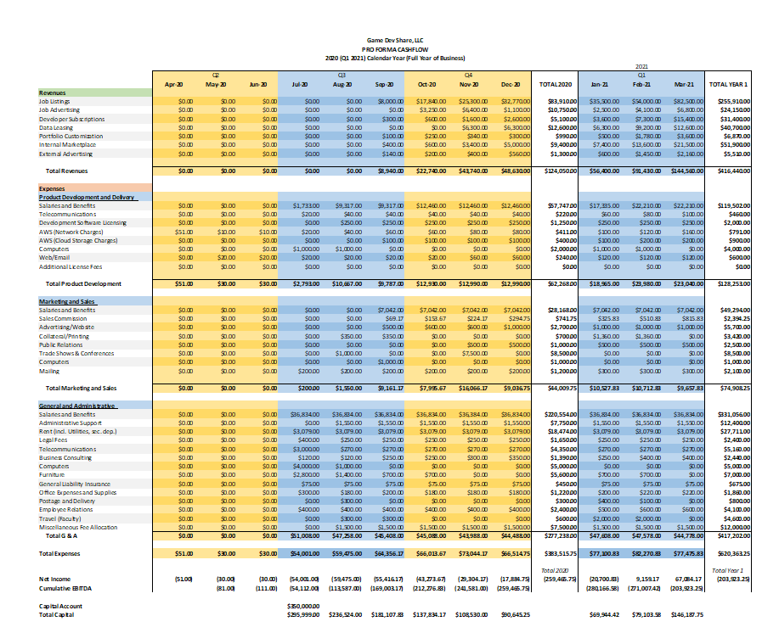

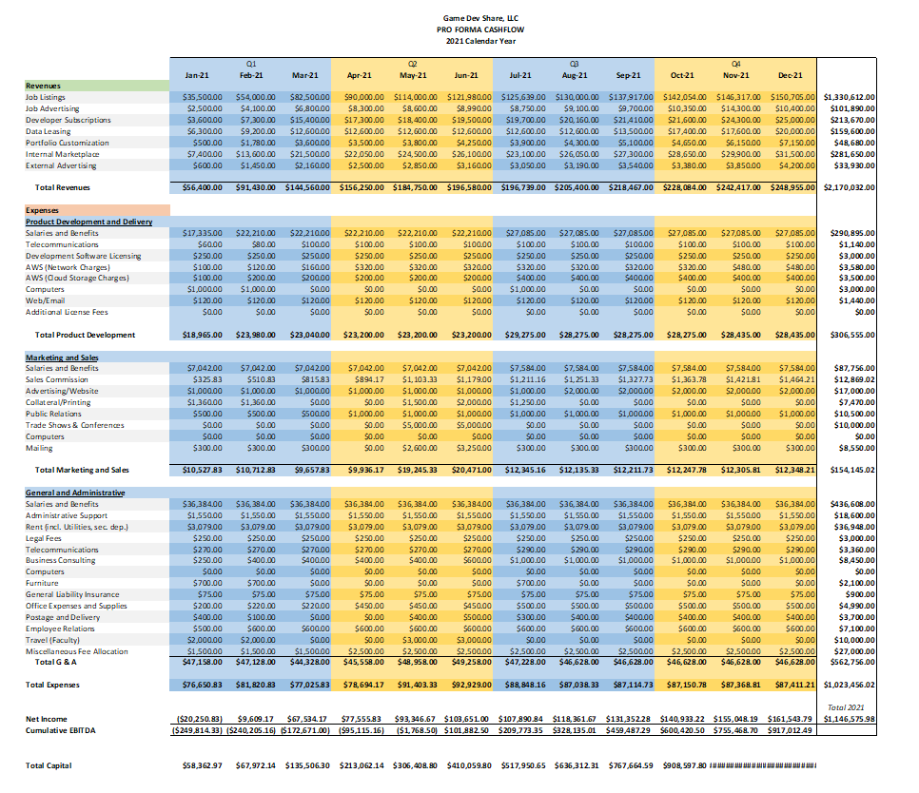

## Financial Assumptions:

### Revenues

* Cash flow will begin at the end of Q3 2020.
* Job Listings are variable and have different tiered options. The free tier will be based on applications, advantage listings start at $500, advantage+ listings start at $1000, and unlimited listings start at $2,000. Companies can also pre-pay for job listings for a discounted price.
* Job Advertising is variable and will change based on an employer’s activity and needs.
* Developer subscriptions start at $10 billed monthly.
* Portfolio customization is variable and starts at $1.
* The internal marketplace will change based on the sales that a user generates, users can list items for free, and will be charged a 40% fee for the sale of the item in the marketplace on Game Dev Share. Businesses will be charged a 20% fee for the sale of each item in the marketplace.
* External advertising uses Google Adsense where income is variable and based on impressions and clicks, it is assumed that based on the number of users, we will generate an increased amount as the number of users increases.

### Operating Expenses - Product Development and Delivery

* Salary expenses are variable, and will not begin until Q3 2020, + denotes an additional employee, - denotes subtracting an employee. PT employees will not be working more than 20 hours per week and will not require benefits.

#### 2020

Apr-20: No Change

May-20: No Change

Jun-20: No Change

Jul-20: + 1 Artist/Designer @ $20/hr @ 20 hours per week = $400 per week (Contracted)

Aug-20: + 1 FT Software Developer @ 70k per year + 30% benefits = 91k

Sep-20: No Change

Oct-20: + 1 FT Customer Service Agent @ 45k per year + 30% benefits = 58.5k

Nov-20: No Change

Dec-20: No Change

#### 2021

Jan-21: + 1 FT Customer Service Agent @ 45k per year + 30% benefits = 58.5k

Feb-21: + 1 FT Customer Service Agent @ 45k per year + 30% benefits = 58.5k

Mar-21: No Change

* Telecommunications are expected to cost $20 per line of VoIP, averaging in cost of $60 per quarter, ramping up to an average of $100 per quarter by the end of 2021 Q1.
* Development software licensing will require licensing of use of SketchFab models and will likely cost an average of $750 per quarter.
* Amazon Web Services (Network Charges) is variable based on instances and location of web servers. The cost of the server prior to release will remain low at approx. $30 per month, $10 for development and $20 for a webmail server. Costs will ramp up at the end of 2020 Q3 to maintain processes for the increase in traffic. Server upgrades thereafter will increase by approx. $20 every two months until peaking at $160 per server during 2021, when a load balancer will be implemented to deal with increased traffic and data access.
* Amazon Web Services (Cloud Storage Charges) will be staggered, increasing to $100 per month at the end of 2020 Q3, then increasing again by an extra $100 per month in 2021 Q1 to deal with increased need, data will be kept and maintained for approx. three (3) years with backups being created every three months and offloaded into hard storage at our corporate headquarters.
* Computers will be purchased as needed and reused for new employees where applicable. We expect each computer to cost around $1000 for a complete setup per employee with dual monitor and built tower.
* Web/Email is listed in the Amazon Web Services (Network Charges), costing $20 dollars for the duration of development, and increasing to $60 mid 2020 Q4, increasing to $120 monthly in 2021 Q1.
* We are not expecting any additional licensing fees.

### Operating Expenses - Marketing and Sales

* Salary expenses are variable, and will not begin until end of Q3 2020, + denotes an additional employee, - denotes subtracting an employee. Marketers have a chance to increase their earnings that they will receive at the end of the year of 10% of the sales they generate.

#### 2020

Apr-20: No Change

May-20: No Change

Jun-20: No Change

Jul-20: No Change

Aug-20: No Change

Sep-20: + 1 FT Marketer @ $65k per year + 30% benefits = 84.5k

Oct-20: No Change

Nov-20: No Change

Dec-20: No Change

#### 2021

Jan-21: No Change

Feb-21: No Change

Mar-21: No Change

* Advertising/Website: Marketers will be budgeted a certain amount of money per month to use for marketing, this will increase as business increases starting in 2020 Q3 at a monthly cost of $500, increasing to $1000 by the end of 2020 Q4, then remaining stagnant until later in 2021.
* Collateral/Printing will be one-time costs per month as an event happens, see Events in our Sales and Marketing Section for a timeline of events. Cost will vary based on the number of prints of flyers and corporate profiles. We expect for our first event to not cost a large amount; however, we do expect our event in the beginning of 2021 to create a lot of more buzz and cost far more.
* Public Relations: Marketers and executives will be budgeted a certain amount of money per month to use for public relations, this includes handling further advertising and minor events such as meetups as well as handling press.
* Tradeshows and conferences: this expense includes the cost of registering for a booth at conferences as well as the booth cost itself such as graphics and ‘swag.’
* Computers will be purchased as needed and reused for new employees where applicable. We expect each computer to cost around $1000 for a complete setup per employee with dual monitor and built tower.
* Mailing is variable and is expected to change from month to month with the most costly months being around events/tradeshows.

#### Operating Expenses - General and Administrative

* Salaries are based on four executive salaries at 85k per year with 30% benefits, costing a total of $442k per year.
* Administrative assistant is expected to cost $1550 per month starting 2020 Q3. Administrative assistants will aid in scheduling meetings, taking reception calls, etc. and will be part time working 20 hours per week @ $17.50 per hour = $350 per week (18k/yr)
* Office will be located at 4455 Brookfield Corporate Center Building 2 Ste. 55, Chantilly VA, 20151 United States. The office will cost $3,097 per month for a 1997 sqft office space at a rate of $1.54 per month per sqft. The office contains one conference room, four private offices, and an open office space. Utilities are included in the rent.

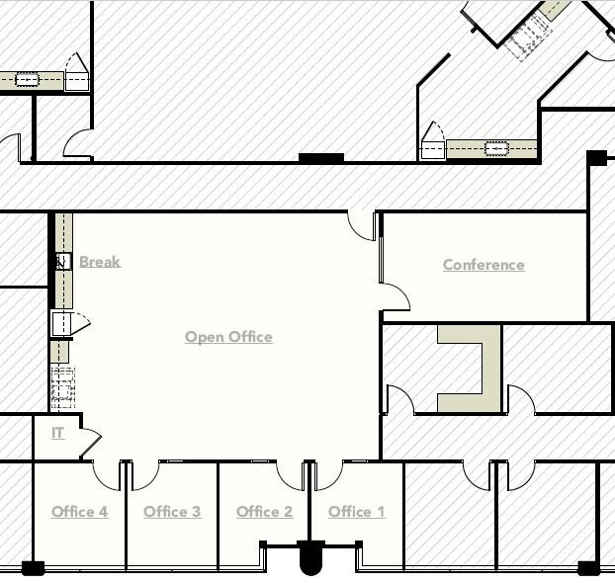

* Legal fees include our business registration fees, trademark registration fees, and legal office monthly fees. Expected Business Registration Fees of $200 one-time, then $50 per year thereafter. Expected retainer to cost around $250 monthly.
* Telecommunications are expected to cost around $20 per person monthly and internet is expected to cost around $170 per month for the first three years. This includes VoIP service. Telecommunications will also have an initial cost of $3000 for networking equipment and cabling.
* Business consulting fees are expected to be variable and increase as business increases.
* Computers will be purchased as needed and reused for new employees where applicable. We expect each computer to cost around $1000 for a complete setup per employee with dual monitor and built tower.
* Furniture will be purchased as needed and reused for new employees where applicable. We expect each person’s workstation to cost around $700 for a complete setup per employee, including an office chair, desk, filing cabinet, etc.
* General Liability Insurance we expect to cost around $900-$1,000 per year
* Office supplies are expected to cost around $20 per month per employee, incurring an initial cost of $300 for the first month.
* Postage and delivery is expected to be variable, with most of the upfront costs at the time of events for event booths and collateral/printing. Event booths will be reused where applicable.
* Travel is expected to be variable depending on location of events, this includes the cost of hotels, flights, event access, etc. Employees will be reimbursed if their own vehicle is used to travel at the rate listed on the GSA government website. <https://www.gsa.gov/travel/plan-book/transportation-airfare-pov-etc/privately-owned-vehicle-pov-mileage-reimbursement-rates>
* Miscellaneous Fee Allocation is a monthly savings fee to cover unexpected fees or license fees that were not originally intended. This amount may also be used to cover maintenance fees, software fees, etc. Depending on the month to month misc fees, the rest of this money will be placed in business savings. The coverage will be about $1,500, which will roll into the following month.

### Further Assumptions

* Benefits at 30% for senior managers
* Cash flows assume receivables and payables at 30-day net
* We are expecting to lose $204k in the first year of operations and begin seeing a positive net income in Q1 2021.